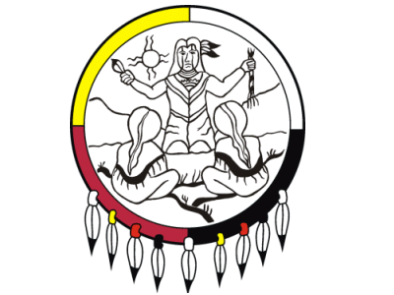
ANISHINABEK EMPLOYMENT & TRAINING SERVICES
Free Aboriginal Training Program Information Session
Date: _________________________________
Name:

Mailing Address: | Please select applicable First Nation:  - Animbiigoo Zaagi'igan Anishinaabek (Lake Nipigon)  - Biinjitiwaabik Zaaging Anishinaabek (Rocky Bay)  - Bingwi Neyaashi Anishinabek  (Sand Point)  - Kiashke Zaaging Anishinaabek  (Gull Bay)  - Michipicoten First Nation  - Ojibways of the Pic River First Nation  - Pays Plat First Nation  - Pic Mobert First Nation  - Red Rock Indian Band
City:

Postal Code:
Telephone Number: | Email Address:
Special Diet:

